**Experiment no. 04**

* 1. **Experiment Name**

Experimental study of Pulse width and Pulse code modulation and demodulation techniques

* 1. **Objectives**
* To combine message and carrier frequencies, send the signal, receive the same signal, and separate the message signal
* To get acquainted with pulse width modulation and demodulation techniques
* To get acquainted with pulse code modulation and demodulation techniques
* To observe input and output waveshapes of both techniques individually
  1. **Theory**

**PWM, or pulse width modulation**, is a modulation process or technique used in most communication systems to encode the amplitude of one signal (the carrier signal) into the pulse width or length of another signal (the source signal).

It is really used to adjust the amplitude of digital signals in order to control power or electricity-requiring equipment and applications. Demodulating PWM requires converting it to pulse amplitude modulation (PAM) and passing it through a low pass filter.

The PWM signal was generated using the square generator and the monostable multivibrator circuits. A decoder or demodulator in the receiver circuit is required to recover the original audio signal from a PWM pulse. We can regulate the breadth of the pulse if we can control the time fluctuation of the electric level. When the amplitude of the audio signal increases, so does the pulse width.

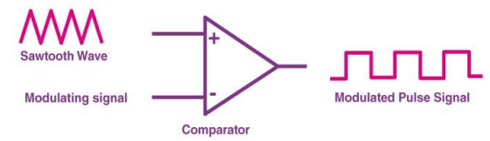

Fig.04.1: Generation of PW modulated signal

PCM stands for **Pulse Code Modulation**. To study pulse modulation and demodulation, a pulse code modulator and demodulator kit is utilized. Pulse code modulation is a technique for converting an analog signal into a digital signal. Because PCM is binary, there are only two conceivable states: high and low (0 and 1). Demodulation can also be used to recover our analog signal.

The steps of generating PCM are,

**Filtering (Low Pass Filter) – Sampling – Quantization -- Encoding.**

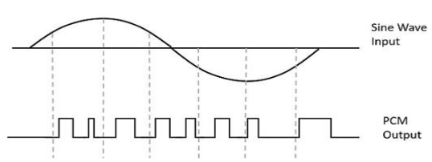

Fig.04.2: Generation of PC modulated signal

* 1. **Apparatus**
* Oscilloscope
* Pulse Width modulation and demodulation kit
* Pulse Code modulation and demodulation kit
* Jumper Wires
  1. **Block Diagram & Kit**

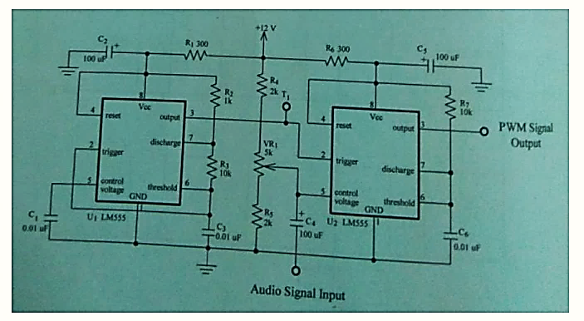

Fig.04.3: Block diagram for PW modulation and demodulation

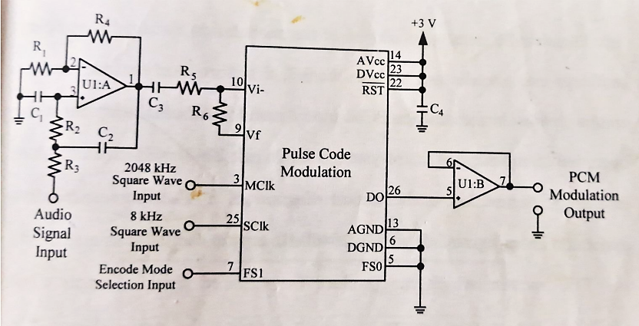

Fig.04.4: Block diagram for PC modulation

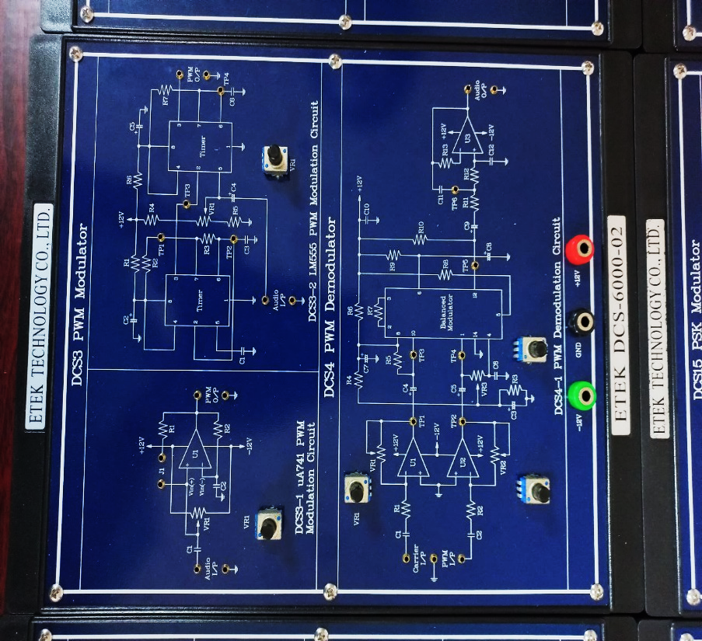 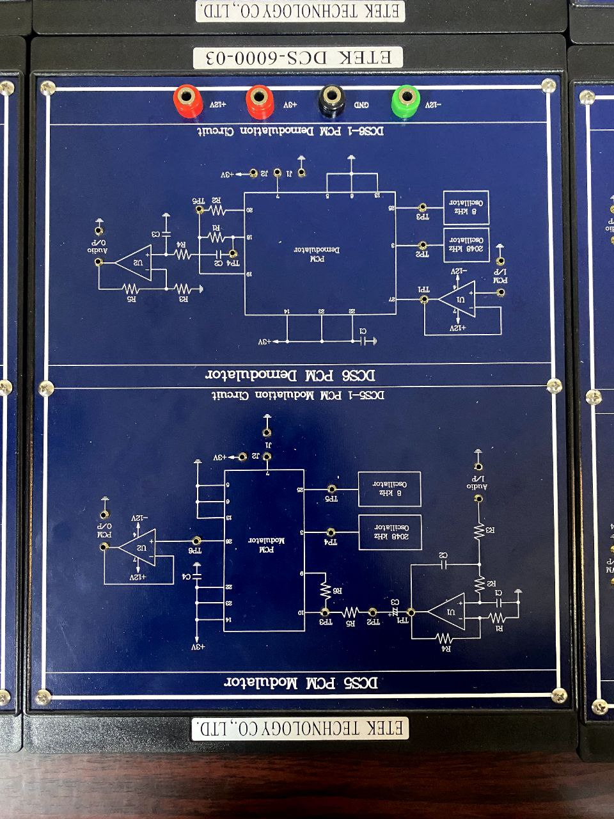

Fig.04.5: PW modulation and demodulation kit Fig.04.6: PC modulation and demodulation kit

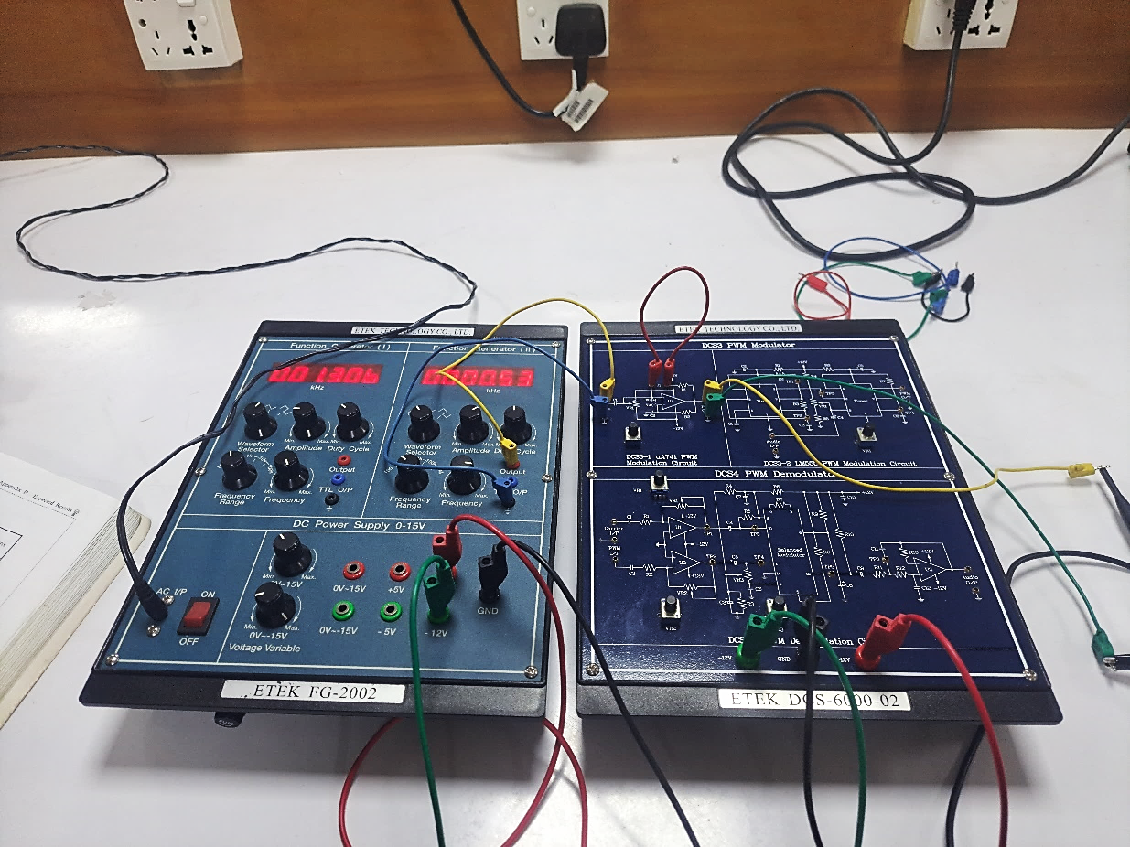

Fig.04.7: Experimental Setup of Pulse Width modulation and demodulation Experiment

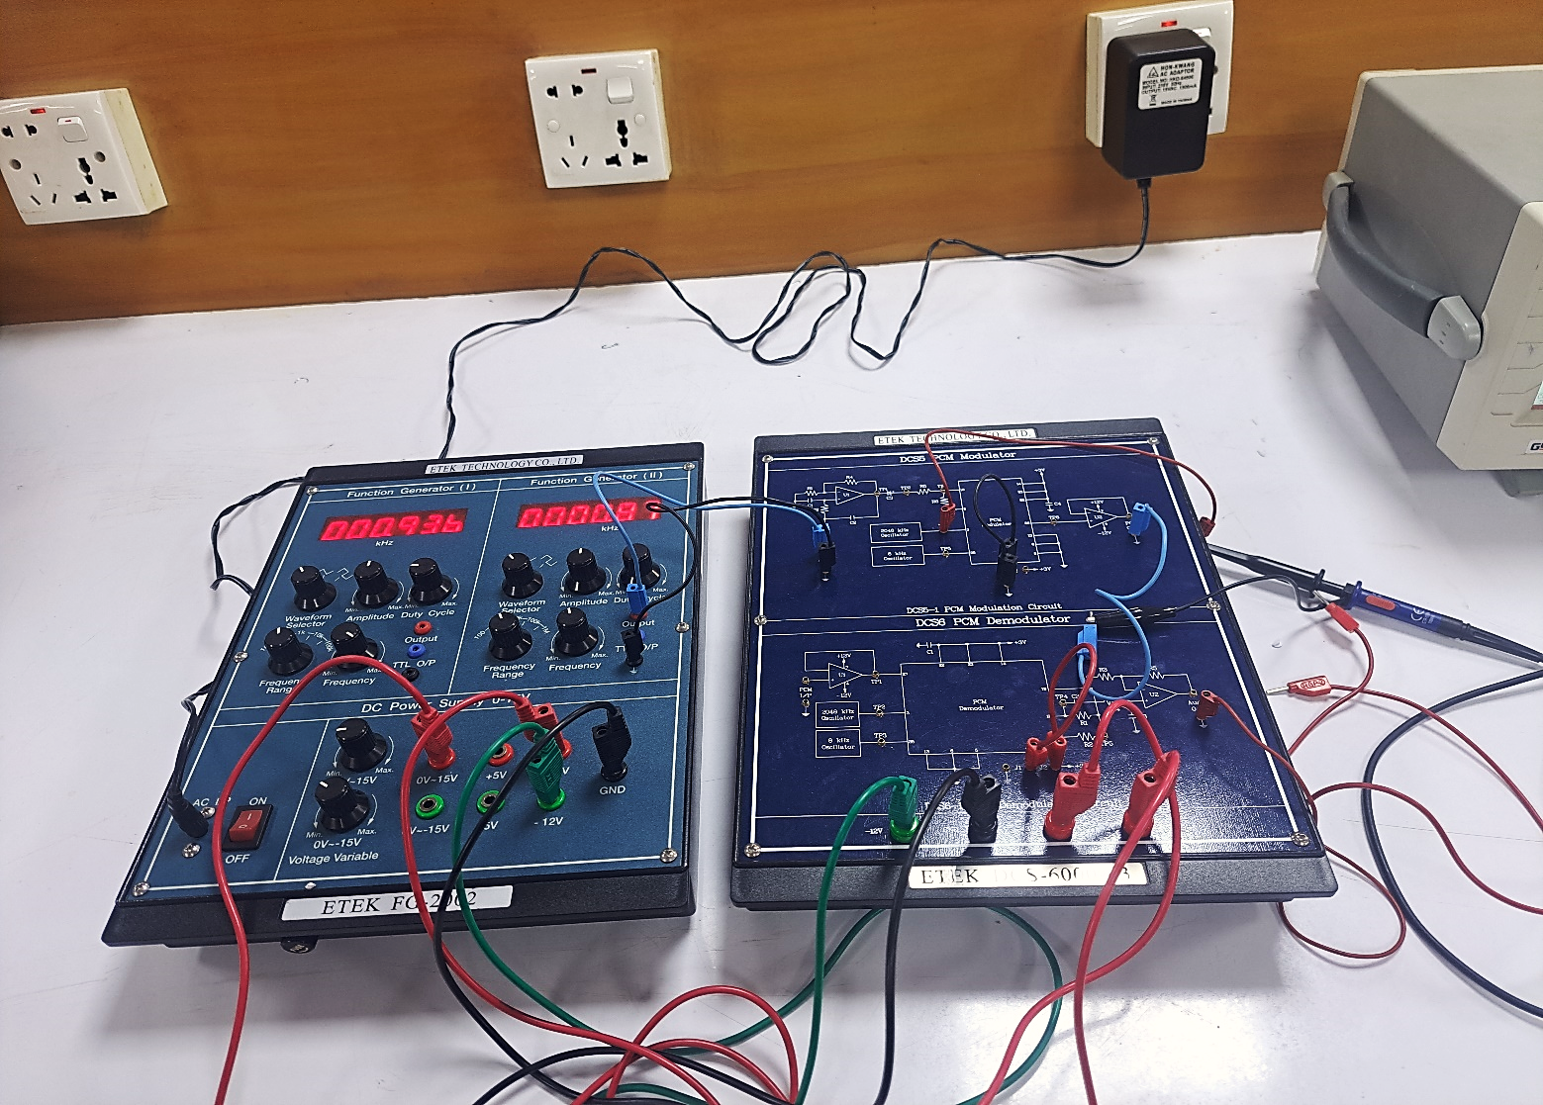

Fig.04.8: Experimental Setup of Pulse Code modulation and demodulation Experiment

* 1. **Waveforms**
* **PWM**

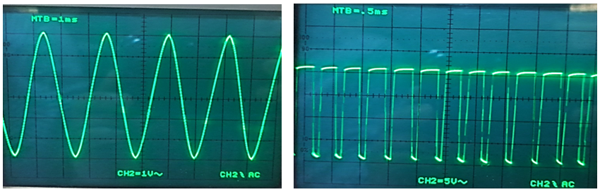

Fig.04.9: 6V input PWM voltage Fig.04.10: 6V output PWM voltage

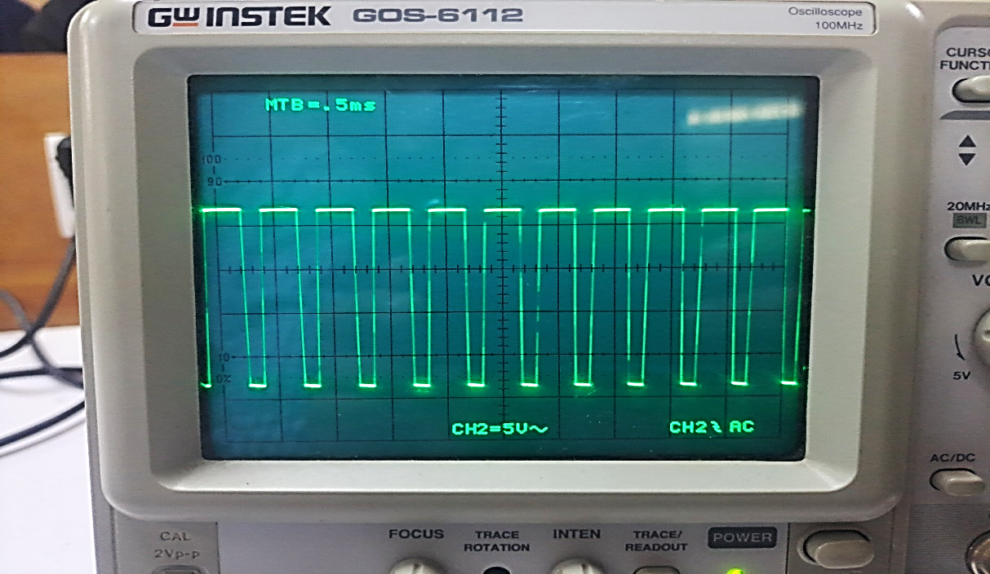 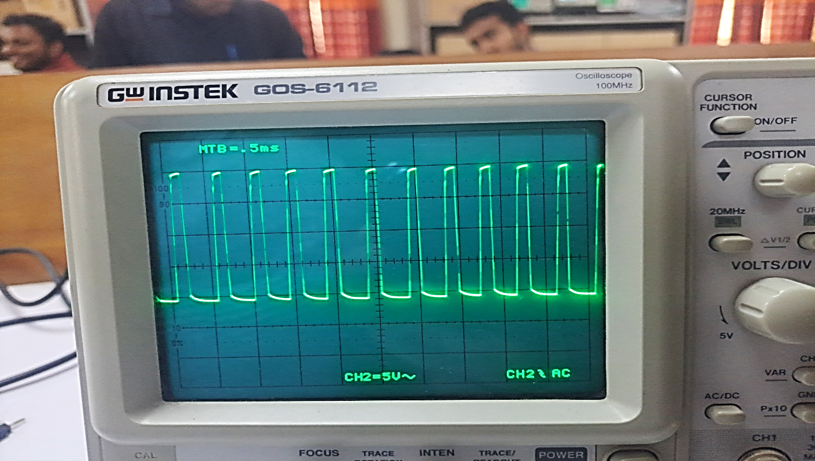

Fig.04.11: 0V output PWM voltage Fig.04.12: -6V output PWM voltage

* **PCM**

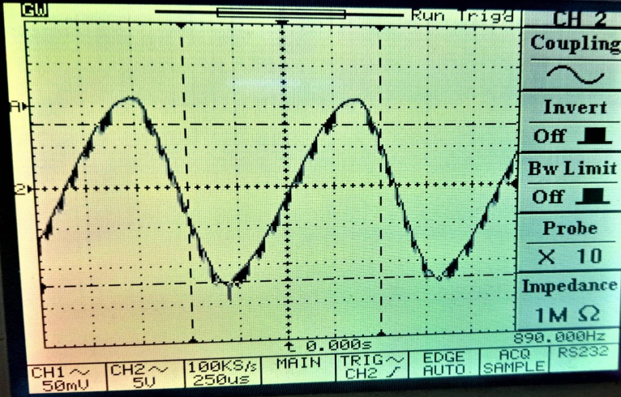 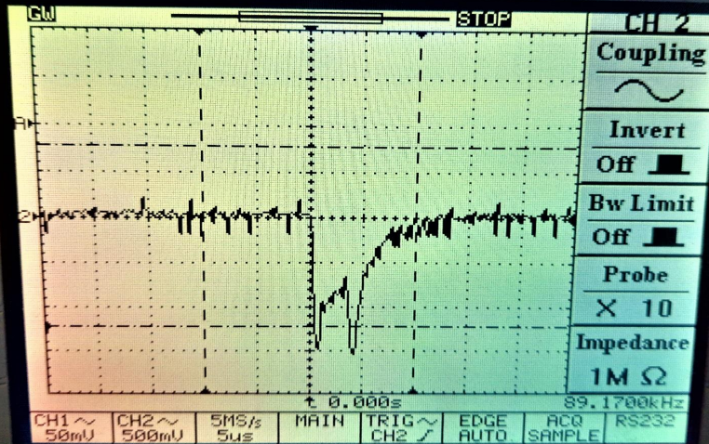

Fig.04.13: Input PCM voltage Fig.04.14: Output PCM voltage

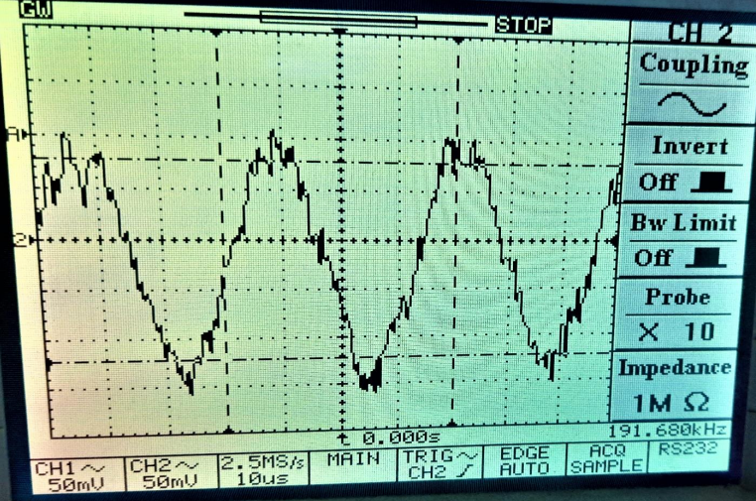

Fig.04.15: Output PCDM voltage

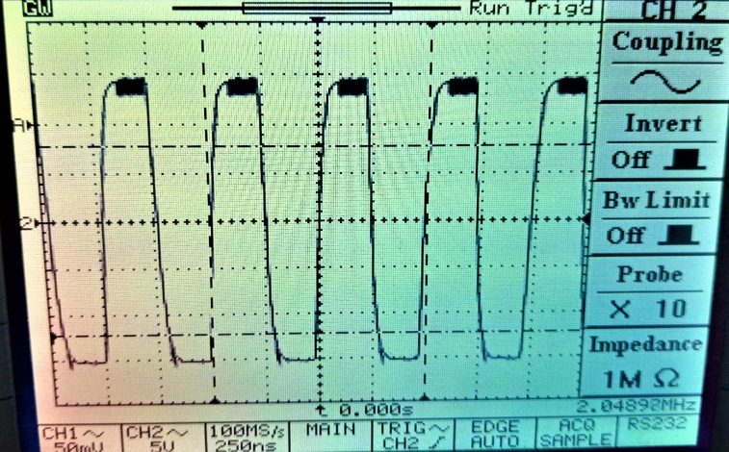 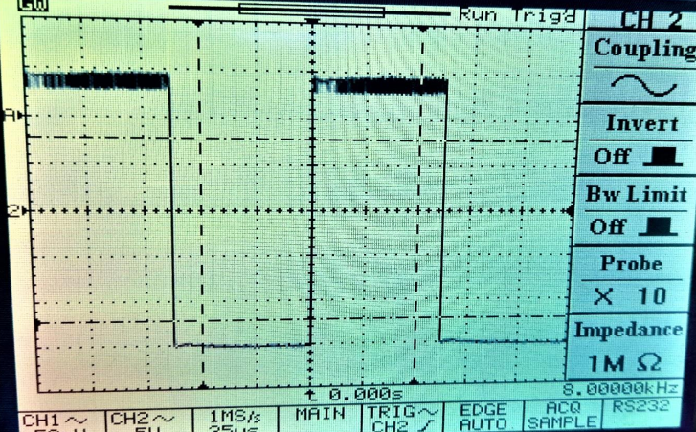

Fig.04.16: TP4 type PCM technique Fig.04.17: TP5 type PCM technique

* 1. **Discussion & Conclusion**

In this experiment, the functions and purposes of pulse width modulated and demodulated signal through laboratory kits were briefly reviewed. Their operation and working principle were also learnt and discussed.

The first was pulse-width modulation. The input pulse was produced by the signal generator, the output was visible through the scope, and the connections were made in line with the instructions. The pulse code modulation approach was used in the second occurrence. After applying the pulse to the modulator kit, the modulated output was discovered. The modulated data was further demodulated, and the output was examined through the scope. In both situations, the intended output as manual was discovered. As a result, the experiment was carried out correctly.

Thus, experiment was a success.

* 1. **Reference**
* Book: Electronic Communication System- George Kennedy
* Book: Communication Systems – Haykin
* <https://en.wikipedia.org/wiki/Pulse-width_modulation>
* <https://en.wikipedia.org/wiki/Pulse-code_modulation>